Assignments 12

1. Write a query that selects all customers whose ratings are equal to
or greater than ANY of Serres.

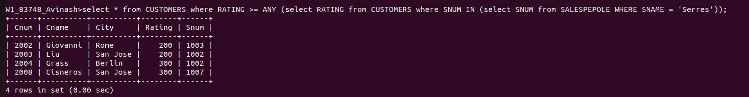

2.Write a query using ANY or ALL that will find all salespeople who
have no customers located in their city.

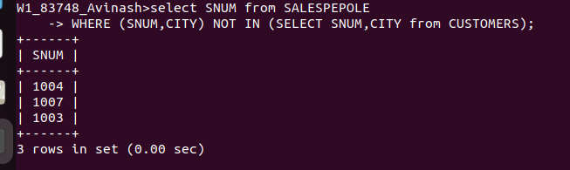

3. Write a query that selects all orders for amounts greater than any
for the customers in London.

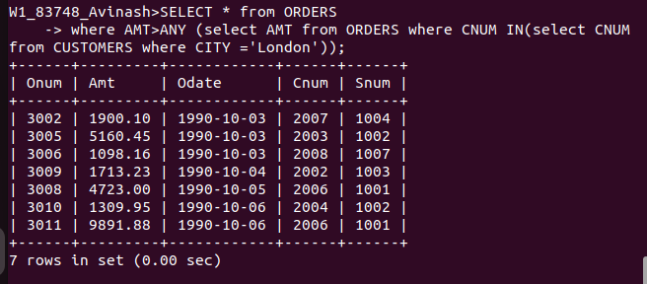

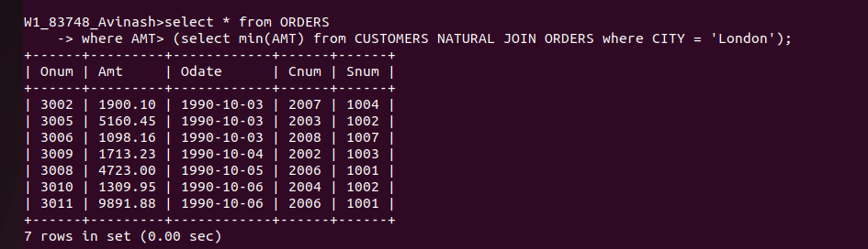
4 .Write the above query using MIN or MAX.

